WEEK-1

MODULE-1

**Exercise 1: Implementing the Singleton Pattern**

**-Logger.java**

**public** **class** Logger {

**private** **static** Logger *instance*;

**private** Logger() {

System.***out***.println("Logger Initialized");

}

**public** **static** Logger getInstance() {

**if** (*instance* == **null**) {

*instance* = **new** Logger();

}

**return** *instance*;

}

**public** **void** log(String message) {

System.***out***.println("[LOG]: " + message);

}

}

**-Main.Java**

**package** SingletonPatternExample;

**public** **class** Main {

**public** **static** **void** main(String[] args) {

Logger logger1 = Logger.*getInstance*();

logger1.log("This is the first log message.");

Logger logger2 = Logger.*getInstance*();

logger2.log("This is the second log message.");

**if** (logger1 == logger2) {

System.***out***.println("Both logger instances are the same.");

} **else** {

System.***out***.println("Different logger instances exist.");

}

}

}

**OUTPUT:**

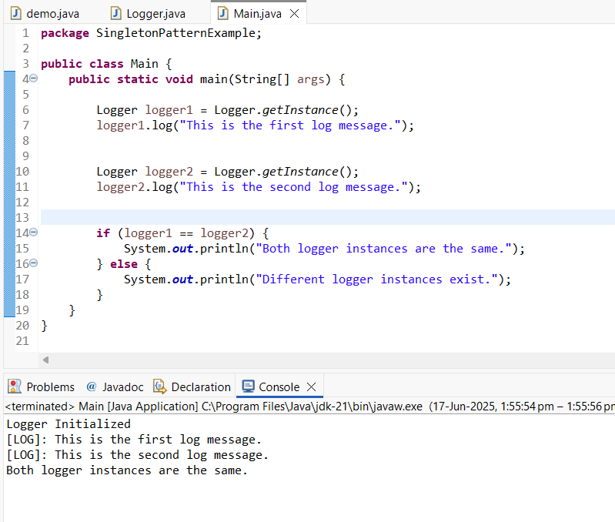

**Exercise 2: Implementing the Factory Method Pattern**

**//documents/Document.java**

package documents;

public interface Document {

void open();

}

**// documents/ExcelDocument.java**

package documents;

public class ExcelDocument implements Document {

public void open() {

System.*out*.println("Opening Excel Document...");

}

}

// documents/PdfDocument.java

**package** documents;

**public** **class** PdfDocument **implements** Document {

**public** **void** open() {

System.***out***.println("Opening PDF Document...");

}

}

//documents/WordDocument.java

**package** documents;

**public** **class** WordDocument **implements** Document {

**public** **void** open() {

System.***out***.println("Opening Word Document...");

}

}

// factory/DocumentFactory.java

**package** factory;

**import** documents.Document;

**public** **abstract** **class** DocumentFactory {

**public** **abstract** Document createDocument();

}

// factory/ExcelDocumentFactory.java

**package** factory;

**import** documents.Document;

**import** documents.ExcelDocument;

**public** **class** ExcelDocumentFactory **extends** DocumentFactory {

**public** Document createDocument() {

**return** **new** ExcelDocument();

}

}

// factory/PdfDocumentFactory.java

**package** factory;

**import** documents.Document;

**import** documents.PdfDocument;

**public** **class** PdfDocumentFactory **extends** DocumentFactory {

**public** Document createDocument() {

**return** **new** PdfDocument();

}

}

// factory/WordDocumentFactory.java

**package** factory;

**import** documents.Document;

**import** documents.WordDocument;

**public** **class** WordDocumentFactory **extends** DocumentFactory {

**public** Document createDocument() {

**return** **new** WordDocument();

}

}

Main.Java

**import** documents.Document;

**import** factory.*;

**public** **class** Main {

**public** **static** **void** main(String[] args) {

DocumentFactory wordFactory = **new** WordDocumentFactory();

Document word = wordFactory.createDocument();

word.open();

DocumentFactory pdfFactory = **new** PdfDocumentFactory();

Document pdf = pdfFactory.createDocument();

pdf.open();

DocumentFactory excelFactory = **new** ExcelDocumentFactory();

Document excel = excelFactory.createDocument();

excel.open();

}

}

**OUTPUT:**

